Commodore PET/CBM80xx/40xx A/V-Interface **Rev. 2**

**Module Description**

The PET A/V-Interface allows to output composite video and audio signals from the user port of the PET. Non-CRTC machines, like the PET 20xx or CBM30xx are outputting video information, which can be mixed to an NTSC video signal (Figure 5).

CRTC machines, like most CBM40xx and CBM80xx do not follow any video standard, they generate 50 FPS, but the horizontal rates do not fit any video standard. They require a different edit ROM to meet either PAL or NTSC. With this new edit ROM, the built in monitor will not synchronize. It is recommended to switch off the supply voltage of the monitor, while the PAL or NTSC edit ROM is active.

The audio signal is derived from the CB2 output of the User Port, which is widely used to produce audio with PET or CBM machines. The amplitude of the audio signal is approximately 0.6V. The signal is not suitable to directly drive a speaker, an amplifier is required. It is recommended to try out low volume setting first and adjust the volume to taste. Both J7/white and J6/red are identical, since there is no stereo output. It is desirable to connect the audio signal to both stereo channels of the audio/video equipment.

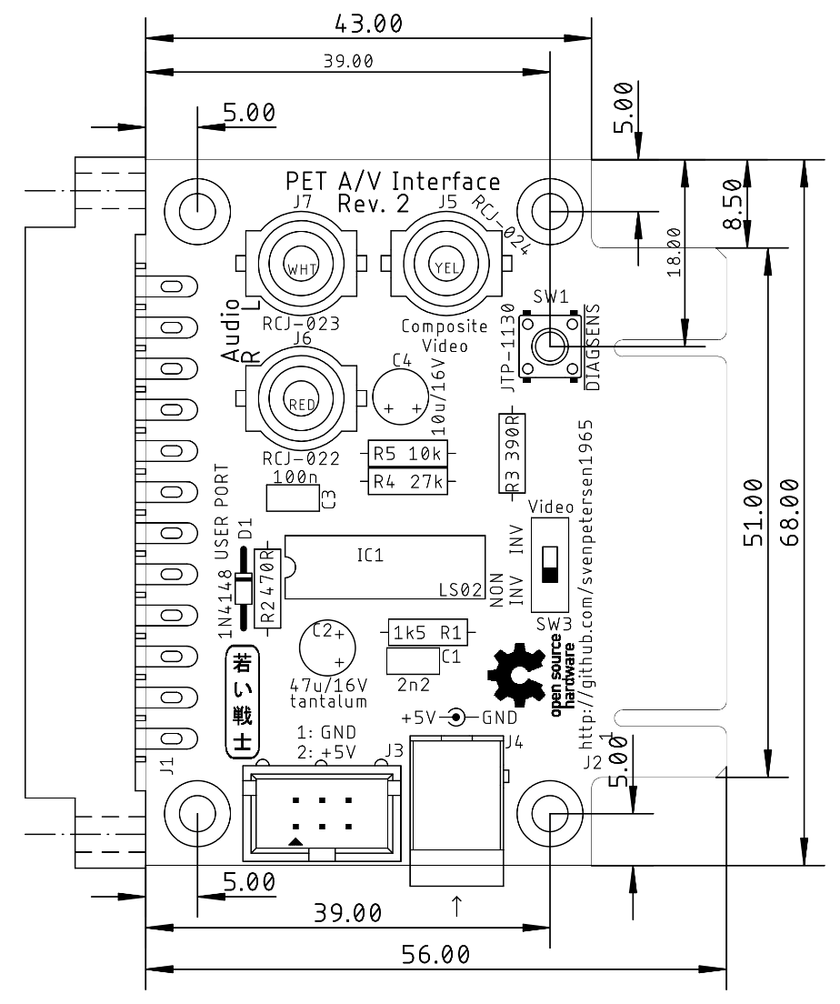

Figure 1: Dimensions of the PET A/V Interface

The A/V Interface requires a supply voltage of 5V, since the PET user port does not have a +5V pin (like the C64 user port). There are two ways to get 5V to the circuit:

1. Tap the Cassette Port with the Cassette Port dongle of the C64 Diagnostic Harness (which is pass through), a Datassette can still be used.
2. A 5V power supply with a 5.5mm/2.5mm barrel jack (inner lead is +5V).

The User Port of the PET is passed through and can be fully used on the edge connector of the board.

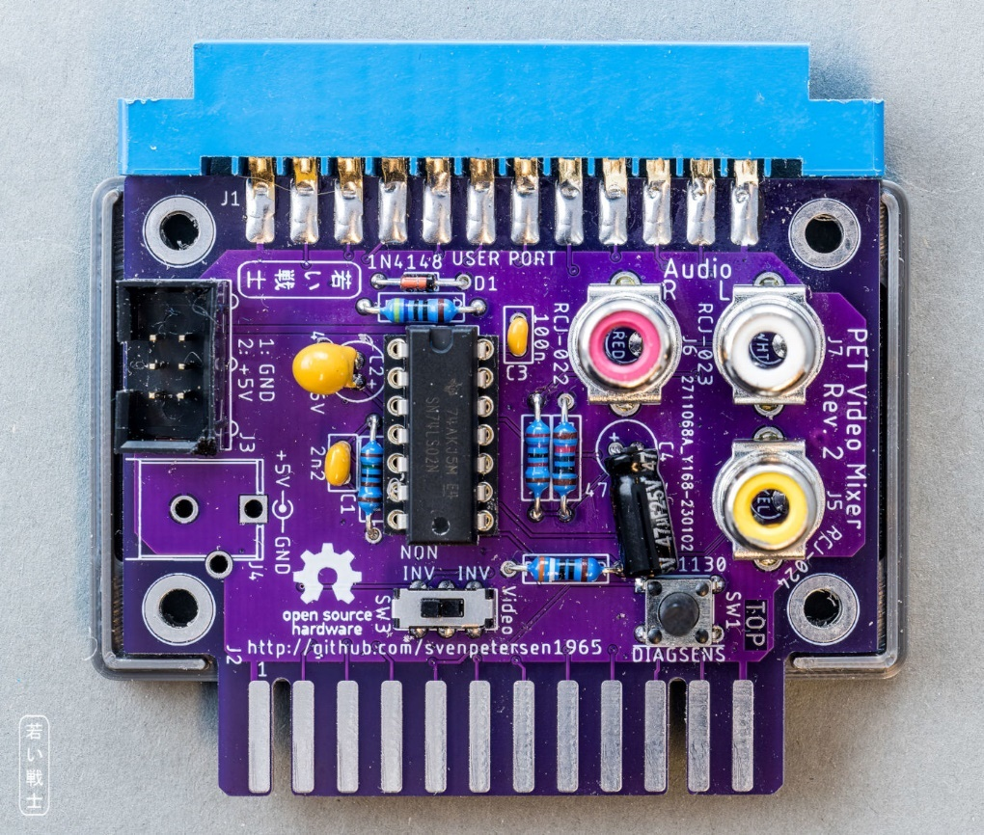

Figure 2: PET A/V Interface Rev. 2 with power via cassette port/box connector (J3)

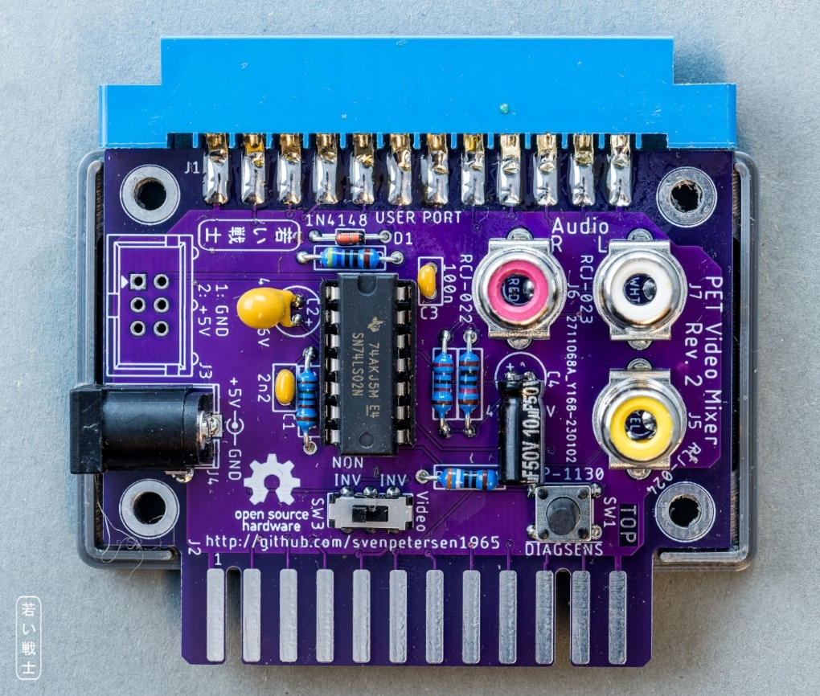

Figure 3: PET A/V Interface Rev. 2 with barrel connector (J4)

**Note:** C2 has to be a tantalum capacitor

**Note:** C4 has to be put flat to fit into the 3D printed case (Figure 2, Figure 3)

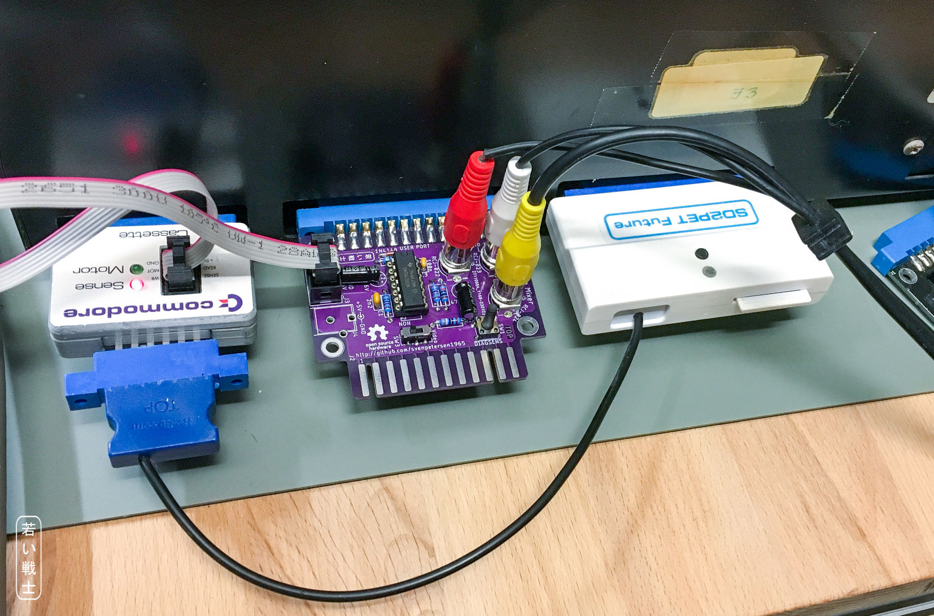

Figure 4: PET A/V Interface on CBM3016, powered from Cassette port (and SD2PET Future Floppy Disk emulator)

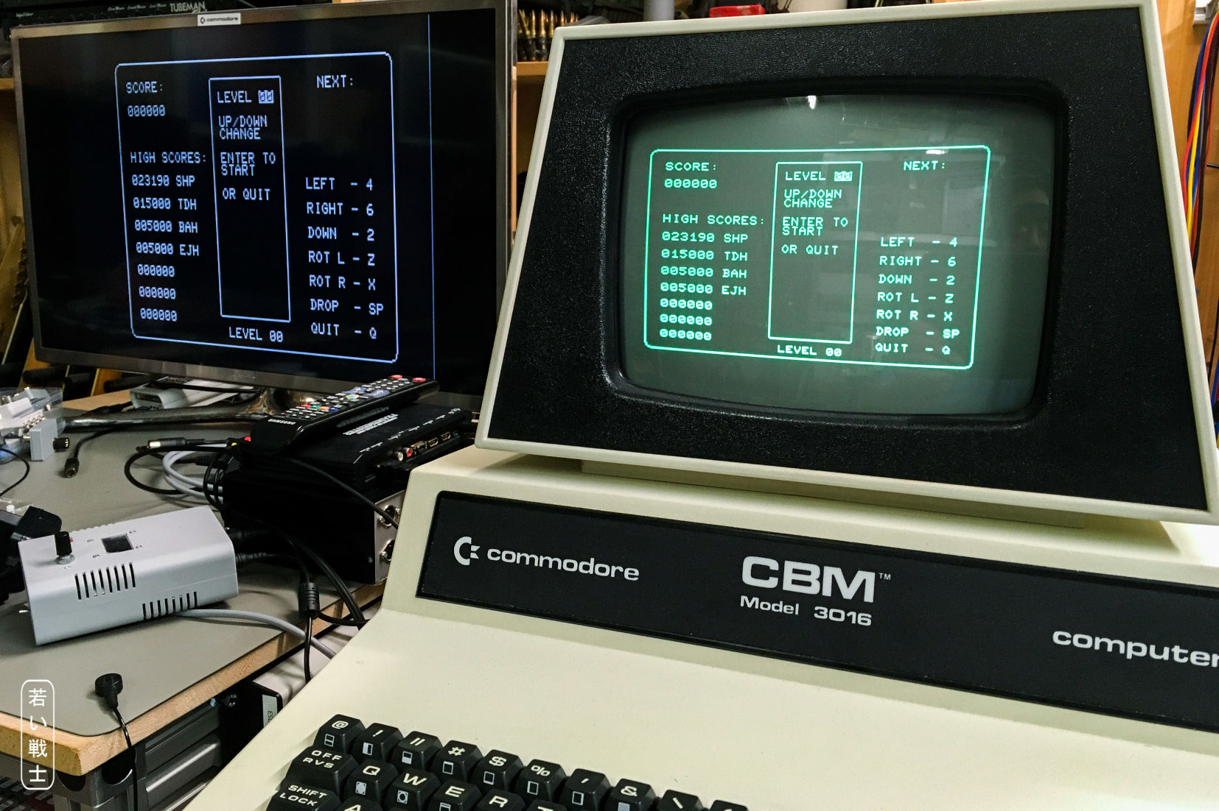

Figure 5: CBM3016 monitor and video output on a Framemeister HDMI adapter

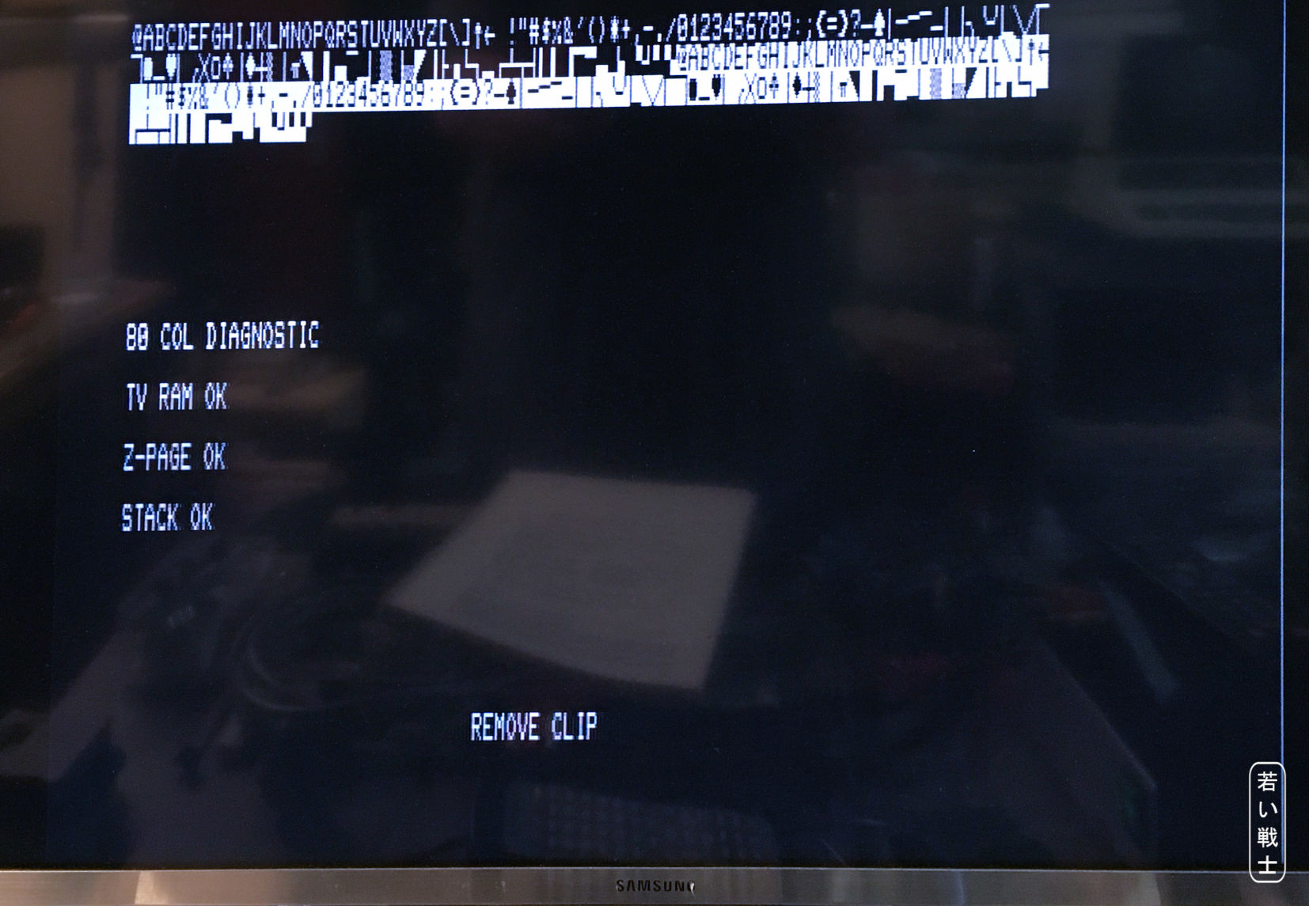

Figure 6: Output of a CRTC machine with edited parameters for NTSC output (the diagnostic clip software)

The CRTC parameters for an NTSC (60Hz) output were derived from Steve Gray’s [Edit ROM](https://github.com/sjgray/cbm-edit-rom/blob/master/crtc-reg-normal.asm) project: <https://github.com/sjgray/cbm-edit-rom/blob/master/crtc-reg-normal.asm>

**Note:** It is advised to disconnect and switch off the supply voltage of the CBM 40xx/80xx monitor while operating the mainboard with these modified parameters, since the monitor cannot sync on NTSC. It makes a strange noise instead.

# Connectors

## J1 – PET User Port

2x12 Pin edge connector, 3.96mm pitch

|  |  |  |  |
| --- | --- | --- | --- |
| Signal | Pin (top) | Pin (bottom) | Signal |
| GND | 1 | A | GND |
| TVVIDEO | 2 | B | CA1 |
| IEEESRQ | 3 | C | PA0 |
| IEEEEOI | 4 | D | PA1 |
|  | 5 | E | PA2 |
| TPREAD2 | 6 | F | PA3 |
| TPWRITE | 7 | H | PA4 |
| TPREAD1 | 8 | J | PA5 |
| TVVERT | 9 | K | PA6 |
| TVHOR | 10 | L | PA7 |
|  | 11 | M | CB2 |
| GND | 12 | N | GND |

## J2 – PET User Port (through)

2x12 Pin board connector, 3.96mm pitch

|  |  |  |  |
| --- | --- | --- | --- |
| Signal | Pin (top) | Pin (bottom) | Signal |
| GND | 1 | A | GND |
| TVVIDEO | 2 | B | CA1 |
| IEEESRQ | 3 | C | PA0 |
| IEEEEOI | 4 | D | PA1 |
|  | 5 | E | PA2 |
| TPREAD2 | 6 | F | PA3 |
| TPWRITE | 7 | H | PA4 |
| TPREAD1 | 8 | J | PA5 |
| TVVERT | 9 | K | PA6 |
| TVHOR | 10 | L | PA7 |
|  | 11 | M | CB2 |
| GND | 12 | N | GND |

## J3 – Power connector (from cassette port)

2x3 pin box connector

|  |  |  |  |
| --- | --- | --- | --- |
| **Signal** | **Pin** | **Pin** | **Signal** |
| GND | 1 | 2 | +5V |
| - | 3 | 4 | - |
| - | 5 | 6 | - |

This connector is optional. It is not required, if the barrel connector J4 is installed.

Powering from cassette port is the preferred way, since it switches off together with the PET. This requires a Cassette Port Dongle (see [C64 Diagnostic harness](https://github.com/svenpetersen1965/C64-Diagnostic-Rev.-586220-Harness)).

## J4 - +5VDC Power

5,5mm/2,5mm barrel connector (Cliff FCR681465P)

|  |  |
| --- | --- |
| Pin | Signal |
| Center | +5VDC |
| Shaft | GND |

This is an alternative power connector, which can be used with an external +5V power supply. It is not the preferred way of powering the module.

## J5, J6, J7 – Audio and Video RCA jacks

3 RCA jacks

|  |  |  |  |  |
| --- | --- | --- | --- | --- |
| **Connector** | **Color** | **Center** | **Ring** | **Type** |
| J5 | Yellow | Composite video | GND | CUI Inc. RCJ-024 |
| J6 | Red | Audio | GND | CUI Inc. RCJ-022 |
| J7 | White | Audio | GND | CUI Inc. RCJ-023 |

Note: The CUI Inc connectors are pretty wide spread and available from Mouser and Digikey etc. There are acceptable and cheaper connectors from AliExpress, which perfectly fit into the footprint. Click [URL](https://de.aliexpress.com/item/1005004200016377.html?spm=a2g0o.order_list.order_list_main.18.24af5c5fNYe7Mw&gatewayAdapt=glo2deu)

# Switches

## SW1: DIAGSENS

In case SW1 is pushed while power up or reset, the PET boots into the TIM monitor. This might be useful for debugging. The switch is a 6x6mm TACT switch. The appropriate stem height is 13mm, for the 3D printed case.

## SW3: Video non-inverted/inverted

The non CRTC PET models (CBM20xx/30xsx) provide a non-inverted video output on the user port, while the CRTC PET models (like the CBM 40xx or 80xx) provide an inverted signal, which requires to be inverted once more. This can be accomplished with setting SW3.

|  |  |
| --- | --- |
| **Model** | **SW3** |
| PET 20xx | non inverted |
| CBM 30xx | non inverted |
| CBM 40xx | inverted |
| CBM 80xx | inverted |

The micro slide switch is a MSS22D18 (through hole, vertical) type, which is widely available from Ali Express. Click [URL](https://de.aliexpress.com/item/32955334146.html?spm=a2g0o.order_list.order_list_main.66.24af5c5fNYe7Mw&gatewayAdapt=glo2deu)

# 3D Printed Case

There are two versions:

* Power supply via box connector J3/cassette port
* Power supply via 5.5mm/2.5mm barrel connector J4/external PSU

The **recommended screws** are (four) C 2.9x9.5H, DIN 7981 self-tapping screws.

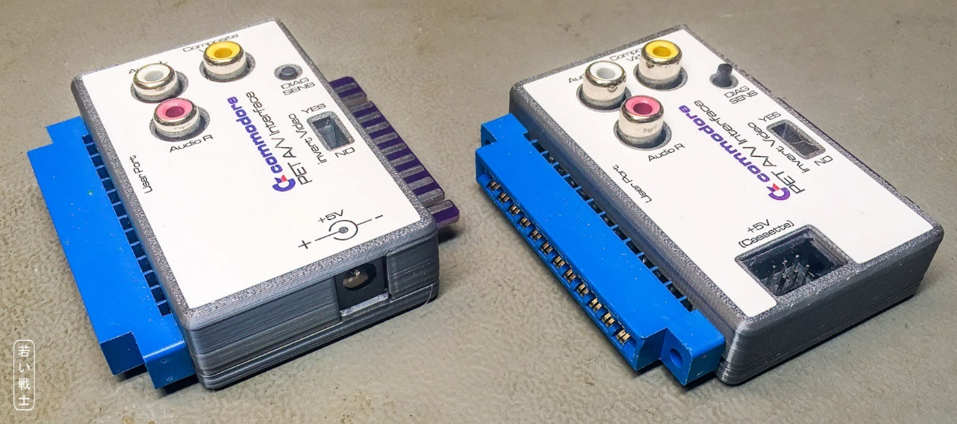

Figure 7: The two different case types: Barrel connector (left), box connector (right)

# Sources

The basic circuit was derived from the PET Video Mixer by Commodore Pet Users Club of England (Newsletter issues 1 & 2, page 9).

# Revision history

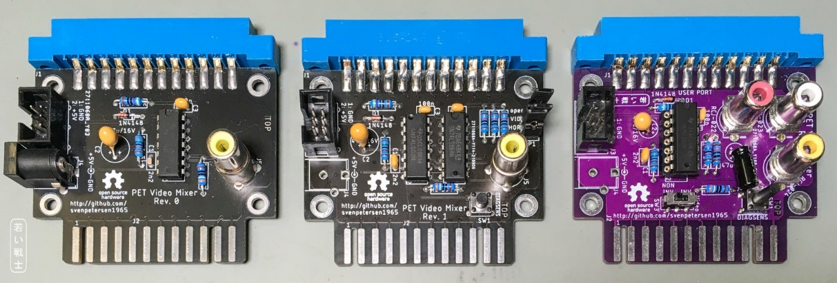

Figure 8: Rev. 0 (left), Rev. 1 and Rev. 2 (right)

## Rev. 0

* Prototype, original PET Video Mixer circuit with pass through user port and power supply connectors. Working with CBM3016 (and other non CRTC models)

## Rev. 1

* Experimental version: Inverted and non-inverted TVVIDEO, TVVERT and TVHOR signals selectable via jumpers

## Rev. 2

* Renamed to PET-A/V Interface
* Audio outputs added
* TVVIDEO switchable between inverted and non-inverted
* 3D printed case available